**EXPERIMENT - 9**

**AIM OF THE EXPERIMENT:**

Implement the monostable multivibrator using IC555

**APPARATUS REQUIRED:**

PC loaded with multisim software

**THEORY:**

Monostable multivibrator using IC 555 has one stable and one quasi stable state. The circuit is useful for generating single output pulse of time duration in response to a triggering signal. The width of the output pulse depends only on external components connected to the op-amp. The diode gives a negative triggering pulse.

When the output is +Vsat, a diode clamps the capacitor voltage to 0.7V then, a negative going triggering impulse magnitude Vi passing through RC and the negative triggering pulse is applied to the positive terminal. Let us assume that the circuit is instable state. The output V0i is at +Vsat. The diode D1 conducts and Vc the voltage across the capacitor ‘C’ gets clamped to 0.7V,the voltage at the positive input terminal through R1R2 potentiometer divider is +ßVsat.

Now, if a negative trigger of magnitude Vi is applied to the positive terminal so that the effective signal is less than 0.7V.the output of the Op-Amp will switch from +Vsat to –Vsat. The diode will now get reverse biased and the capacitor starts charging exponentially to –Vsat.

When the capacitor charge Vc becomes slightly more negative than –ßVsat, the output of the op-amp switches back to +Vsat. The capacitor ‘C’ now starts charging to +Vsat through R until Vc is 0.7V.

V0 = Vf + (Vi-Vf)𝑒𝑡/𝑅𝐶 , ß = R2/(R1+R2)

If Vsat >> Vp and R1=R2 and ß = 0.5,

Then, T = 0.69RC

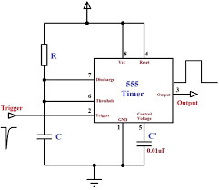

**Implementation:**

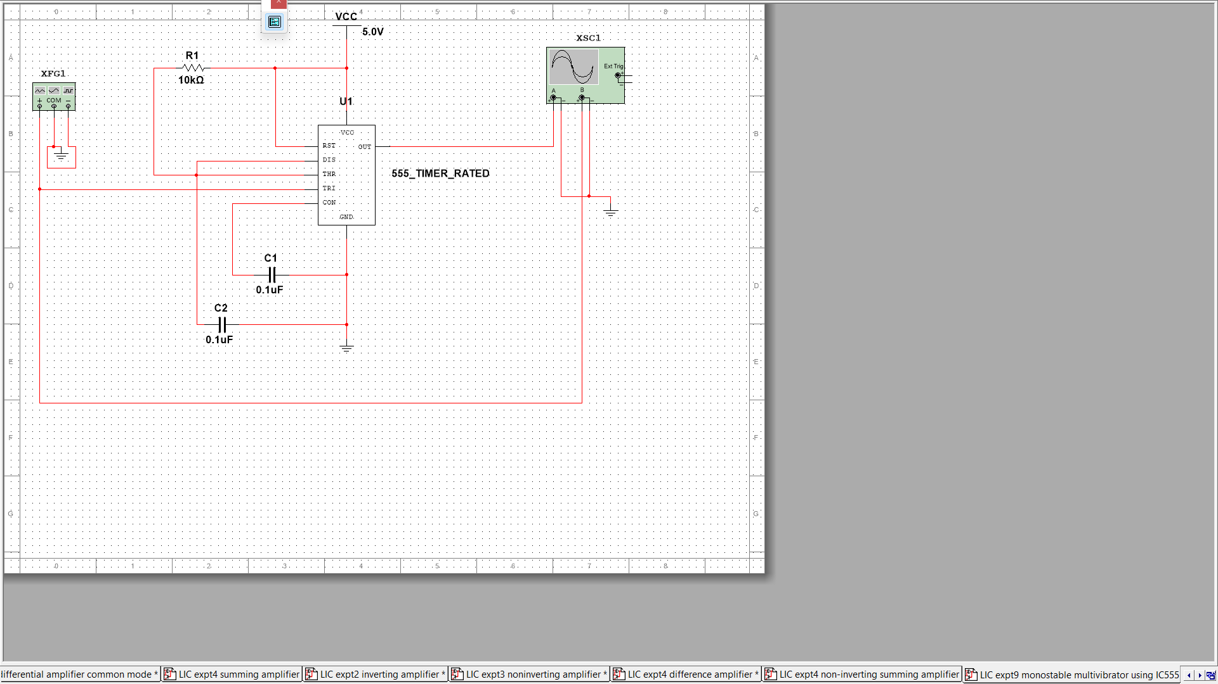Circuit Diagram

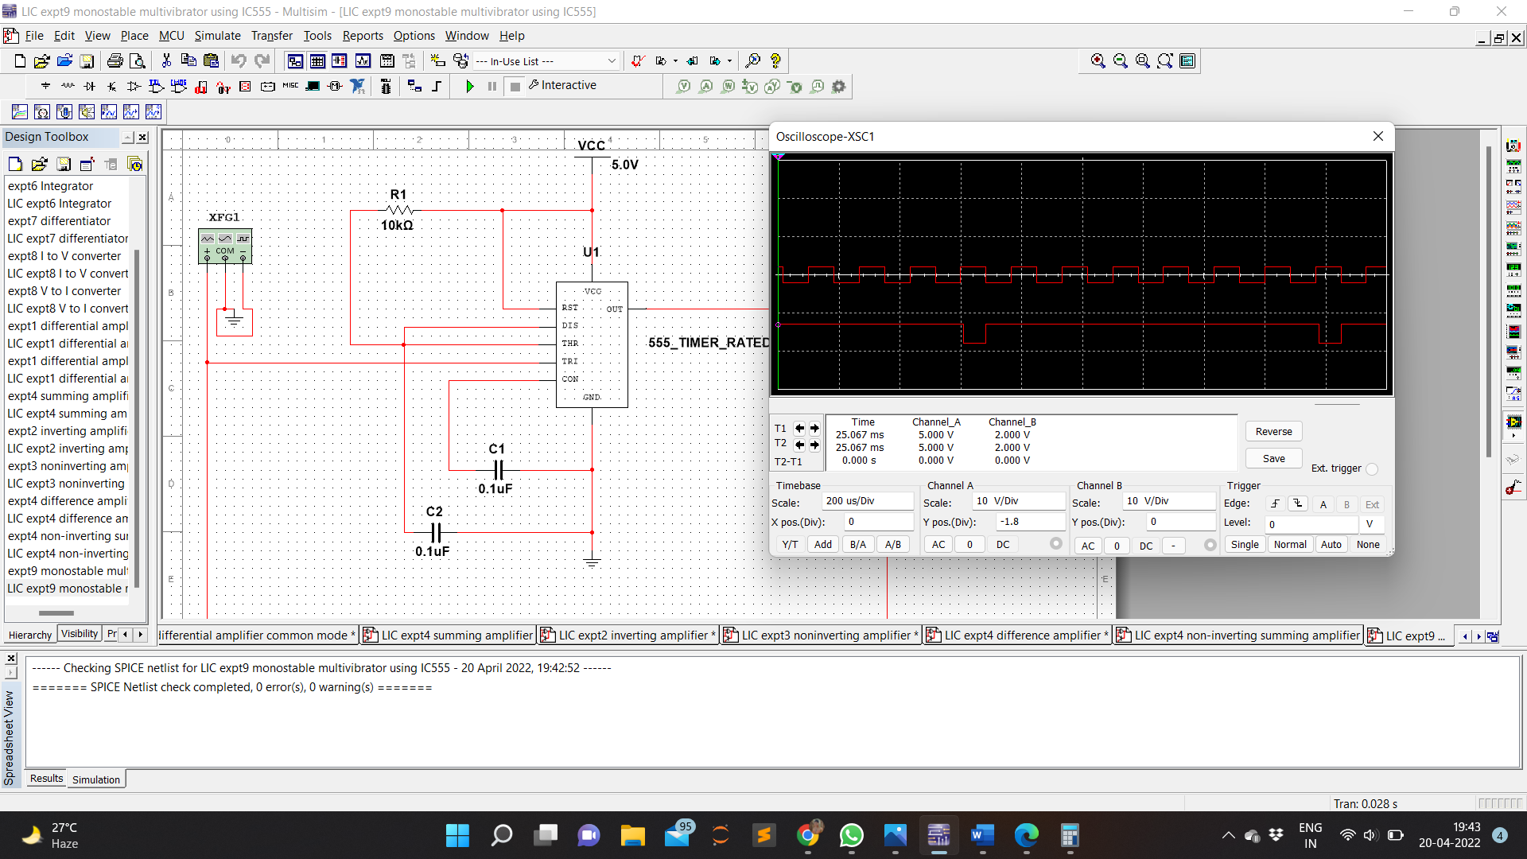Waveform

**RESULT:**

Monostable multivibrator was implemented with the help of IC555 Timer using multisim and simulated.